# Latoria Judkins

CS 255

SNHU

4/21/24

# CS 255 System Design Document Template (Project 2)

## UML Diagrams

### UML Use Case Diagram

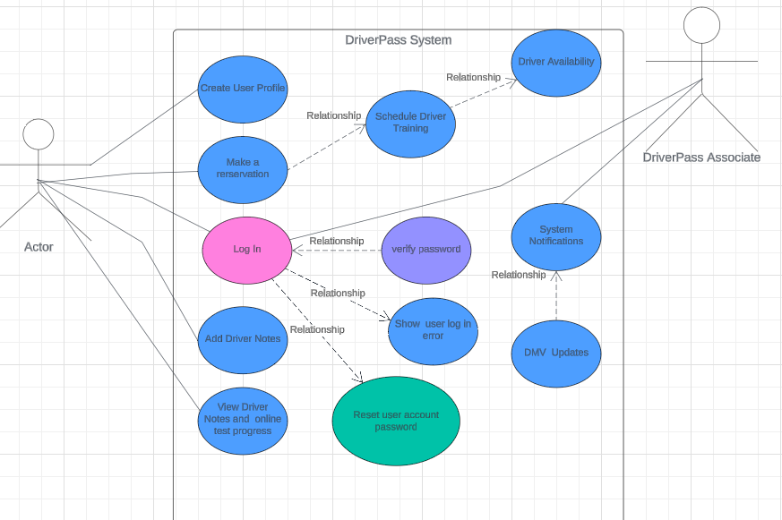

### UML Activity Diagrams

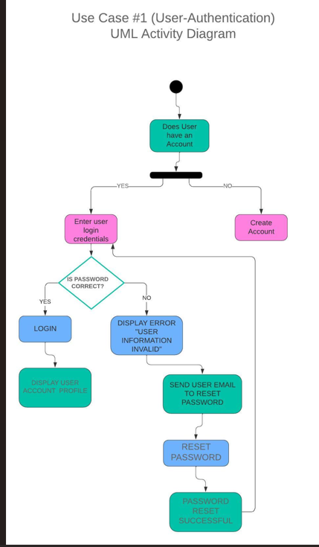

### UML Sequence Diagram

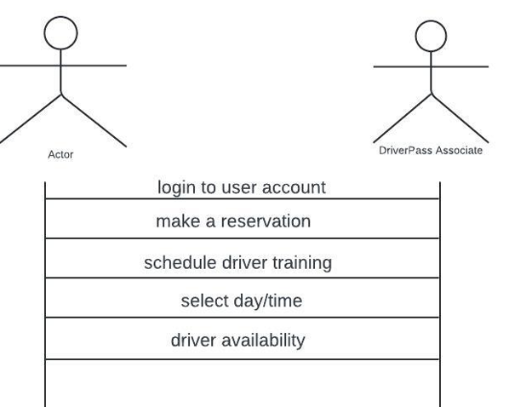

### UML Class Diagram

## Technical Requirements

*Hardware Requirements:*

* *Internet Source*
* *Cloud database and server*
* *Mobile or CPU device*
* *Power source*

*Software Requirements:*

* *Operating System*
* *DriverPass software compatibility with all web browsers*

*Tools:*

* *Computer/Mobile device*
* *Internet Connection*
* *Power Source*
* *Credit card processing system*

*Necessary Infrastructure:*

* *Cloud based server and security*
* *Credit card processing system*